Part 1 : Write a program that uses nested loops to collect data and calculate the average rainfall over a period of years. The program should first ask for the number of years. The outer loop will iterate once for each year. The inner loop will iterate twelve times, once for each month. Each iteration of the inner loop will ask the user for the inches of rainfall for that month. After all iterations, the program should display the number of months, the total inches of rainfall, and the average rainfall per month for the entire period.
# This program calculates total and average rainfall over a specified number of years.
def get_positive_int(prompt): # Helper function to get a positive integer from user
while True:
try:
val = int(input(prompt))
if val > 0:
return val
print("Please enter a positive integer.")
except ValueError:
print("Invalid input. Enter an integer.")

def get_non_negative_float(prompt): # Helper function to get a non-negative float from user
while True:
try:
v = float(input(prompt))
if v >= 0:
return v
print("Please enter a non-negative number.")
except ValueError:
print("Invalid input. Enter a number.")

def main(): # Main function to calculate rainfall statistics
years = get_positive_int("Enter the number of years: ")
total_inches = 0.0
months = 0

for year in range(1, years + 1): # Loop through each year
print(f"Year {year}:")
for month in range(1, 13): # Loop through each month
inches = get_non_negative_float(f" Month {month} rainfall (in inches): ")
total_inches += inches
months += 1

average = total_inches / months if months else 0.0
print()
print(f"Number of months: {months}")
print(f"Total rainfall: {total_inches:.2f} inches")
print(f"Average monthly rainfall: {average:.2f} inches")

if __name__ == "__main__":
main()
OUTPUT :
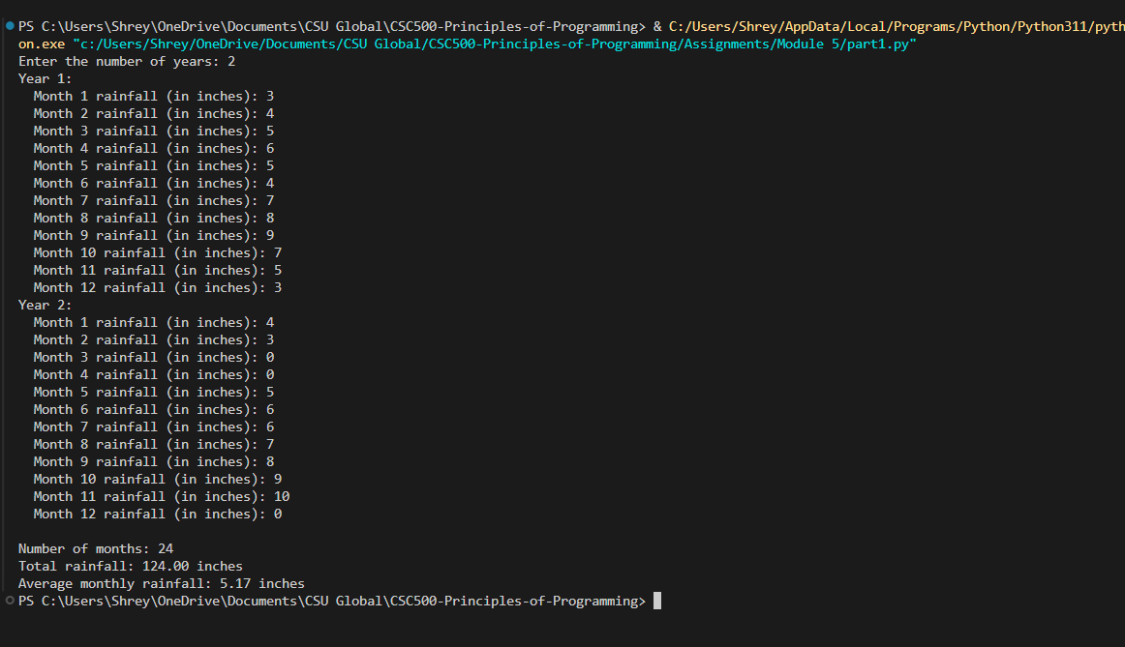

GitHub link : Part 1.py

Part 2 : The CSU Global Bookstore has a book club that awards points to its students based on the number of books purchased each month. The points are awarded as follows:
- If a customer purchases 0 books, they earn 0 points.
- If a customer purchases 2 books, they earn 5 points.
- If a customer purchases 4 books, they earn 15 points.
- If a customer purchases 6 books, they earn 30 points.
- If a customer purchases 8 or more books, they earn 60 points.
Write a program that asks the user to enter the number of books that they have purchased this month and then display the number of points awarded.
# CSU Global Bookstore Book Club Points Program

books = int(input("Enter the number of books purchased this month: "))

if books == 0:
points = 0
elif books == 2:
points = 5
elif books == 4:
points = 15
elif books == 6:
points = 30
elif books >= 8:
points = 60
else:
points = 0

print(f"Books purchased: {books}")
print(f"Points awarded: {points}")

Output :
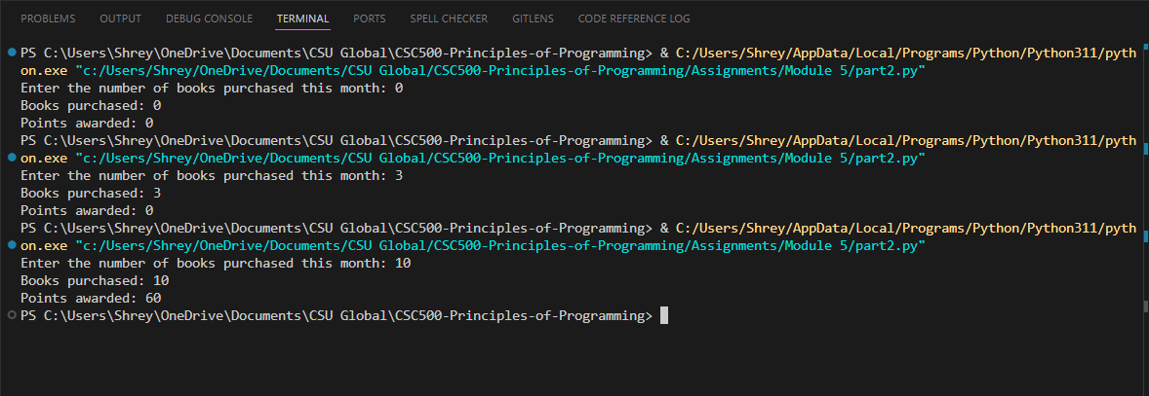

GitHub Link : Part 2.py

